**How to Create Multi-Page Without Duplicating Fonts in ASP.NET PDF**

The Syncfusion Essential; PDF is a comprehensive, high-performance [**.NET PDF library**](https://www.syncfusion.com/document-processing/pdf-framework/net-core) that enables you to create, read, and edit PDF documents. Using this library, you can avoid repeatedly creating fonts in a PDF document, which helps optimize performance.

**Steps to avoid multiple font creation in a PDF document programmatically**

1. Create a new console application project.

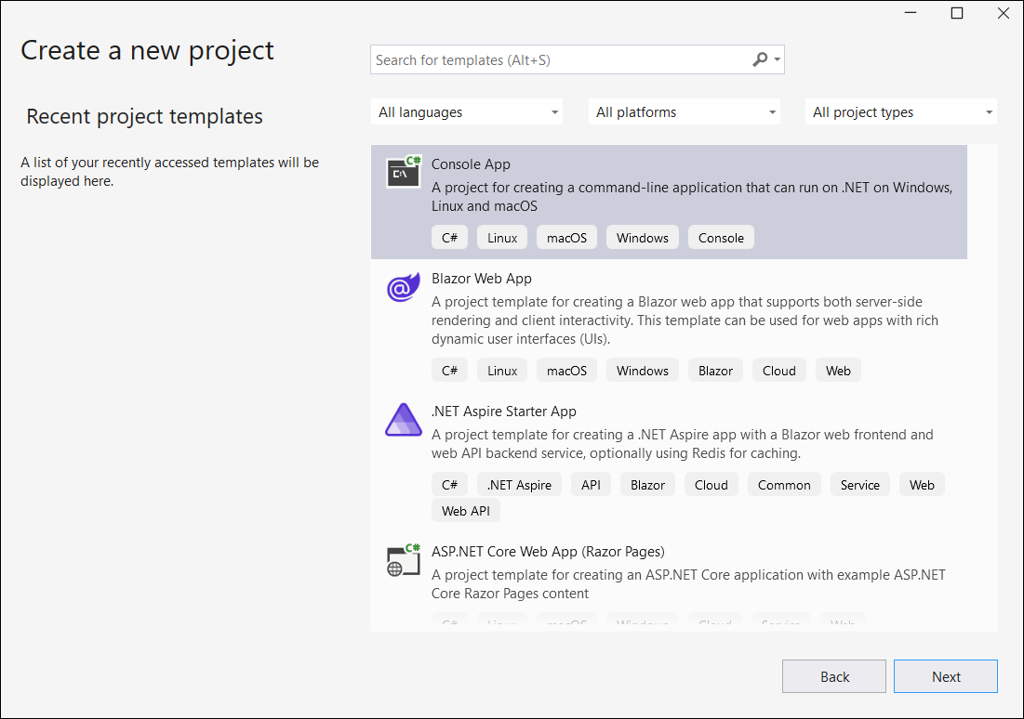

1. Install the **[Syncfusion.Pdf.Net.Core](https://www.nuget.org/packages/Syncfusion.Pdf.Net.Core" \t "_blank)** NuGet package as a reference in your console application from [**Nuget.org**](https://www.nuget.org/).

1. Include the following namespaces in the **Program.cs** file.

**C#**

**using** Syncfusion.Pdf.Graphics;

**using** Syncfusion.Pdf.Interactive;

**using** Syncfusion.Pdf;

**using** Syncfusion.Drawing;

1. Use the following code sample in **Program.cs** to avoid repeatedly creating fonts in a PDF document.

**C#**

// Create a new PDF document

PdfDocument document = **new** PdfDocument();

// Open the font stream once to use it for all pages instead of opening it repeatedly in each iteration

FileStream fontStream = **new** FileStream("Arial.ttf", FileMode.Open, FileAccess.Read);

// Load the font from the font stream with a size of 14

PdfFont font = **new** PdfTrueTypeFont(fontStream, 14);

// Add 10 pages to the PDF document

**for** (int i = 0; i < 10; i++)

{

// Add a new page to the document

PdfPage page = document.Pages.Add();

// Create PDF graphics for the page

PdfGraphics graphics = page.Graphics;

// Create a solid black brush to draw text on the page

PdfBrush brush = **new** PdfSolidBrush(Color.Black);

// Draw the text on the page at coordinates (20, 20), appending the iteration number (i) to each string

graphics.DrawString("Hello world!-" + i, font, brush, **new** PointF(20, 20));

}

// Create a file stream to save the PDF document to a file in the specified output path

**using** (FileStream stream = **new** FileStream("Output.pdf", FileMode.Create, FileAccess.Write))

{

// Save the PDF document to the file stream

document.Save(stream);

}

// Close the document and release resources

document.Close(true);

// Dispose of the font stream to free up resources

fontStream.Dispose();

A complete working sample is available for download from [**GitHub**](https://github.com/SyncfusionExamples/PDF-Examples/tree/master/Text/Avoid-multiple-font-creation-in-PDF/.NET).

By executing the program, you will generate the following PDF document.

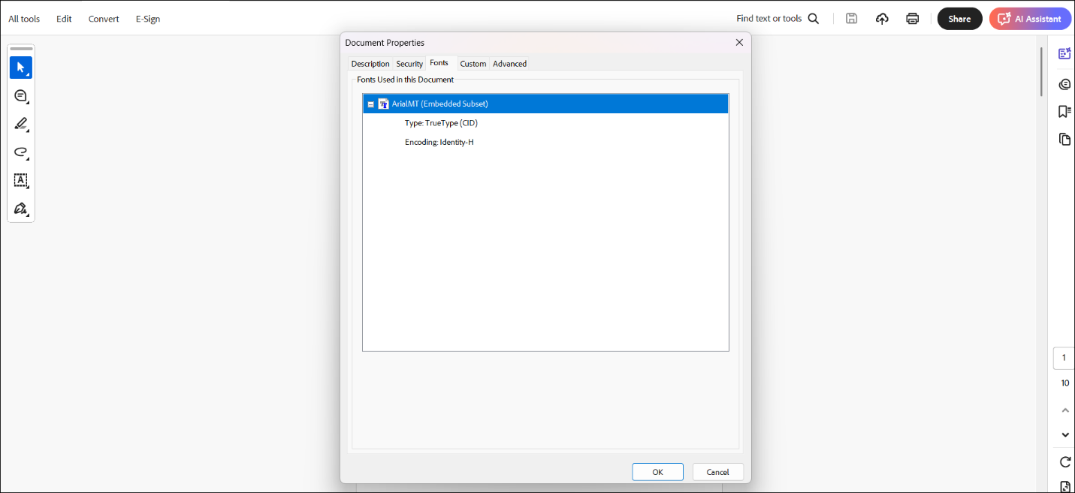

Take a moment to peruse the [**documentation**](https://help.syncfusion.com/document-processing/pdf/pdf-library/net/working-with-text#drawing-text-using-different-fonts) to learn how to add different font in a PDF document.

**Conclusion**  
I hope you enjoyed learning on how to create multi-page without duplicating fonts in [**ASP.NET**](http://asp.net/) PDF.

You can refer to our [**ASP.NET Core PDF feature tour**](https://www.syncfusion.com/document-processing/pdf-framework/net-core) page to know about its other groundbreaking feature representations and [**documentation**](https://help.syncfusion.com/document-processing/pdf/pdf-library/net/create-pdf-file-in-asp-net-core), and how to quickly get started for configuration specifications. You can also explore our [**ASP.NET Core PDF example**](https://ej2.syncfusion.com/aspnetcore/PDF/Default#/bootstrap5) to understand how to create and manipulate data.

For current customers, you can check out our components from the [**License and Downloads**](https://www.syncfusion.com/sales/teamlicense) page. If you are new to Syncfusion®, you can try our 30-day [**free trial**](https://www.syncfusion.com/downloads/aspnetcore-js2) to check out our other controls.

If you have any queries or require clarifications, please let us know in the comments section below. You can also contact us through our [**support forums**](https://www.syncfusion.com/forums), [**Direct-Trac**](https://support.syncfusion.com/create), or [**feedback portal**](https://www.syncfusion.com/feedback/aspnet-core?control=pdf). We are always happy to assist you!